GUA and LLA Structure

I. GUAs are designed for internet-routable communication.
- Global Routing Prefix: This is the network portion of the address, assigned by your internet service provider (ISP). It identifies your network to the internet.
- Subnet ID: This part identifies a specific subnet within your network. It allows you to create multiple subnets for organization and security.
- Interface ID: This uniquely identifies the specific device on the subnet.
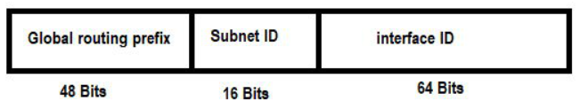
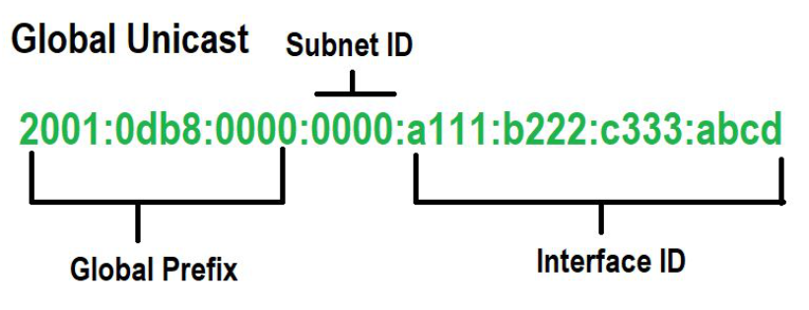
- ID mạng con 16 bit (khuyến nghị ban đầu) = 65.536 mạng con
- ID giao diện 64 bit = 18 nghìn tỷ (18.446.744.073.709.551.616) thiết bị/mạng con.

II.Link-Local Address (LLA) Structure
LLAs are for communication within the same local network segment (link). Their structure is simpler:
- Prefix: This is always FE80::/10, indicating a link-local address.
- Interface ID: This uniquely identifies the device on the local link.

Key Differences in Structure
- Global Routing Prefix: GUAs have this, LLAs don't. This is because LLAs are not meant for routing on the internet.
- Subnet ID: GUAs have this, LLAs don't. This is because LLAs are only used within a single link, so no further subnetting is needed.
- Prefix: LLAs have a fixed prefix (FE80::/10), GUAs have a prefix assigned by your ISP.

Analogy
Think of a GUA like your full postal address (street, city, state, zip code), while an LLA is like your apartment number within your building.
Important Notes
- Both GUAs and LLAs use a 128-bit address format.
- The Interface ID is often derived from the device's MAC address but can be assigned in other ways.

